**CLASS ATTENDANCE MANAGEMENT SYSTEM**

**CASE OF THIKA TECHNICAL TRAINING INSTITUTE**

**KIRUBI LAMECK MWANGI**

**REGISTRATION NUMBER: SCT221-D1-0041/2017**

**SUPERVISOR: PIUS THUKU**

A project report submitted to the Department of Information Technology in the School of open and distance learning in partial fulfilment of the requirement for the award of the degree of information technology Jomo Kenyatta University of Agriculture and Technology.

**AUGUST 2021**

# **DECLARATION**

This proposal is my original work and has not been presented for a degree in any other University

*…………………. …………………*

SignatureDate

This proposal has been submitted for examination with my approval as the University Supervisor

……………… ……………….

Signature Date

**ABSTRACT**

In many institutions, attendance is taken seriously by the management in order to ensure student success, prevent criminal behavior and enable development of social skills. In majority of these institutions, the attendance is considered as part of the coursework. Actually, the Kenya National Examination Council (KNEC) requires that every student attend 75 percent of the scheduled classes before they can be registered for their end of course exams; this therefore calls for a thorough attendance recording system. In Thika Technical Training Institute the attendance, tracking system in use is manual; it uses a physical register booklet where the lecturer captures the student’s names, calls out the name whenever he or she attends the lesson as he marks on the booklet. This method is slow, prone to manipulation and impersonation. Additionally, the attendance register could also get damaged, stolen or lost. Therefore, this project report aims at implementing a fingerprint-based class attendance management system that will help eliminate all the trouble spots reported.

The report represents the research that was done, analysis of the collected data, design and implementation of the system. Student’s registration and attendance capturing procedure has also been demonstrated in this report. The developed system will offer many flexible and convenient features that require only basic knowledge of computer for operation hence the entire teaching staff will find it easy to use with efficiency and effectiveness in their operations.

# **TABLE OF CONTENTS**

**Content**  **Page**

**DECLARATION** i

TABLE OF CONTENTS iii

**LIST OF FIGURES** v

**LIST OF TABLES** vi

**CHAPTER 1: INTRODUCTION** 1

1.1 Background Information 1

1.2 Problem Definition 1

1.3 Proposed Solution 2

1.4 Research Questions 3

1.5 Justification 3

1.6 Project Scope 4

**CHAPTER 2: LITERATURE REVIEW** 5

2.1 Introduction 5

2.2. Theoretical Review/Conceptual framework 5

2.2.1 Biometrics Review 7

2.2.2 Learnability on class management system 9

2.2.3 Aspects of Learnability 9

2.3 Summary 10

2.4 Research Gaps 10

**CHAPTER 3: SYSTEM ANALYSIS AND DESIGN** 11

3.1 Introduction 11

3.2 Systems Development Methodology 11

3.3 Feasibility Study 12

3.4 Requirements Elicitation 15

3.5 Data and System Analysis 16

3.5.1 Data Analysis 16

3.6 System Specifications 19

3.6.1 Hardware and software requirements 20

3.7 System Design 21

3.7.1 Logical Design 21

3.8 Physical Design 24

3.8.1 Database Design 24

3.8.2 Database Entities 25

3.8.2 User Interface 26

3.8.3 Control Design 31

**CHAPTER 4: IMPLEMENTATION AND TESTING** 33

4.1 Introduction 33

4.2 Implementation 33

4.3 System Code Generation 34

4.4 System Testing 36

4.4.1 Testing Cases and Results 37

4.5 Conclusion 39

4.6 Limitation 40

4.7 Recommendations 40

**REFERENCES** 41

**APPENDICES** 42

Appendix 1: Sample Questionnaire for Lecturers 42

Appendix 2: Key Interview Questions for the Management 44

Appendix 3: Installation Guide 45

Appendix 4: Budget and resources 46

Appendix 5: Work Plan 47

# LIST OF FIGURES

Figure 1: Expected Training Hours 17

Figure 2: Actual Training Hours 17

Figure 3: Attendance Percentage per Term Vs Exam Performance 18

Figure 4: System Flow Chart 22

Figure 5: Student Authentication flow chart 23

Figure 6: Student entity interaction with course entity 25

Figure 7: Entity relationship diagram for the entire attendance system 25

Figure 8: Login Form 26

Figure 9: Main Menu with Administrator rights 26

Figure 10: Main Menu with Lecturer rights 27

Figure 11: Staff Registration Function 27

Figure 12: Student Registration Function 28

Figure 13: Course Management Function 28

Figure 14: Search Function in Units registration 29

Figure 15: Student Attendance Taking function 29

Figure 16: Marks Entry Function 30

Figure 17: Example of Input Control 31

Figure 18: Systems Staff Report 32

Figure 19: Gantt chart showing the Development of The System 47

# LIST OF TABLES

Table 1: Cost Benefit Analysis 13

Table 2: Time wasted by Lecturers 16

Table 3: Effects of Class Abseentism in comparison to Exam Performance 18

Table 4: Testing Installation and the Login function 37

Table 5: Student attendance checks 38

Table 6: Data Entry Checks 39

Table 7: Budget and resources 46

# **CHAPTER 1: INTRODUCTION**

## Background Information

Thika Technical Training Institute is a Government Technical Training institute established under the Ministry of Higher Education, Science and Technology. Its mandate is to provide quality training in technical, industrial, vocational and entrepreneurship to students pursuing Diploma and Certificate courses.

Thika Technical Institute has class sessions scheduled to start from 7:00AM running throughout the day up to 5:00 P.M. Each class session is two hours. Learners are expected to attend more than 75% of all the sessions as scheduled in the timetable, for this to be monitored every lecturer has to manually mark the attendance sheet provided as a printout.

## Problem Definition

Thika Technical Training Institute in its delivery of its core mandate which is student training, encounters some student administration challenges in terms of maintaining an up to-date and reliable trainees class attendance records. During a lesson, the Lecturer will call out a booklet containing a list of student’s names and tick for present students. In some cases, the student will be the ones to write their names, registration number to indicate their presence for a particular class. Falsification in student attendance does occur rampantly.

This in itself has great implication in that the students are not well followed up leading to low retention rates, low grades and a less satisfying educational experience and skills hence tarnishing the Institute name to the employment industry and other potential new students.

Stakeholders like Kenya National Examination Council (K.N.E.C), which is the body that evaluates the learners, requires that every candidate meet a minimum of 75% class attendance prior to registration. This is in itself tasking and time consuming to the Lecturers who handle the bulky daily attendance sheets manually. Simple error in this manual data handling leads to an error in a student’s total attendance percentage.

Manual generation of reports on average attendance rates is quite cumbersome and ends up consuming the precious trainer’s time depriving students several hours of classroom activities and learning every term. Additionally too much paperwork leads to consumption of a large office space and makes information retrieval a little time consuming.

The institute registrar’s office admits students manually; students are given a printed form to fill their identification details after which they submit the forms back to the registrar’s office for filling. In the case where the same student is to be authenticated again later in the term, the employee in charge in the registry office will have to peruse through the manual files in search of the record, slowing the process.

## Proposed Solution

To solve the above aforementioned problem, the researcher decided to develop a stand-alone system that incorporates learnability. The class attendance management system will help capture the student’s bio data in a database, enable fingerprint matching and later; the data will easily be used to generate the needed reports.

Through the system, the Lecturer will be able to ascertain that the students attending a class, lab and exam sessions are bonifide students and avoid impersonation.

The developed system will help the Lecturers to update the student’s attendance and enter the end of term marks with efficiency and effectiveness, which are part of learnability principles. Since the system is, intuitive Lecturers will find it easy to track the student’s attendance with ease, generate needed reports and raise an alarm for truant’s to the management.

**Main Objective:**

To implement learnability in class attendance management system

**Specific objectives:**

* To conduct a research on fingerprint technology.
* To develop an interactive desktop-based student attendance application.
* To document the project.

## Research Questions

1. What are the available algorithms in fingerprint biometric identification?
2. What are the principles considered in implementing a fingerprint-based student attendance system?
3. What are the methods of implementing a fingerprint-based scanner in desktop-based applications?

## Justification

The proposed system will identify students by their fingerprint; this will eliminate the use of printed attendance booklets currently on use. One of the risks of using a paper work in class attendance is that it can be easily misplaced, students cheat by responding for each other, thereby defeating the aim of taking the attendance. Tracking and monitoring students time of attendance could be tedious, time consuming and susceptible to error. Thus, the System will drastically reduce the time needed to verify the attendance data.

The system also allows the institution management to track or investigate student class attendance in a particular course thereby enabling them to rectify the situation by providing the necessary interventions. The system provides a high level of security making it impossible for imposters and impersonators from making their ways to lecture halls.

.The attendance system allows the Lecturer to monitor each student attendance with efficiency, track down truants and take the appropriate action. The system will rely on the learnability principle of consistency and therefore drastically reduce the anomalies that are associated with manual booklets marking in which a student who was present is sometimes marked as absent due to Lecturer errors thereby losing the mark per that attendance time.

## Project Scope

The study focused on the development of a class attendance system for Thika Technical training institute located in Thika sub-county in Kiambu County in Kenya. The System will bring efficiency in tracking the student’s attendance, as it will eliminate the manual registers.It will be a desktop application developed using C# and MySQL as the preferred database management system. It does not cover other aspects of biometric and learner’s management as the developer is a student, and the project might go beyond his capability in terms of both time and finances.

# **CHAPTER 2: LITERATURE REVIEW**

## 2.1 Introduction

This chapter presents a discussion of the literature review on implementation of a class management system that is aimed at ensuring information security and data integrity. Information security is concerned with the assurance of confidentiality, integrity and availability of information in all forms (www.education.stateuniversity.com, Monday, May 4, 2016).Many tools and techniques exist that can support the management of information security; but system based on biometric has evolved to support some aspects of information security. (Newman, R. (2010))

*Benefits of biometric systems*

According to Newman, biometric authentication supports the facet of identification, authentication and non-repudiation in information security. Biometric authentication has grown in popularity as a way to provide personal identification. Person’s identification is crucially significant in many applications and many areas. Biometric is used to identify the identity of an input sample when compared to a template, used in cases to identify specific people by certain characteristics. Standard validation systems often use multiple inputs of samples for sufficient validation, such as particular characteristics of the sample. Therefore, the advantage claimed by biometric authentication is that they can establish an unbreakable one-to-one correspondence between an individual and a piece of data.

## 2.2. Theoretical Review/Conceptual framework

Class attendance facilitates learning in a variety of ways. Lectures supplement reading assignments. Classroom presentations present information differently than the text. Discussion and elaboration of topics provides current information that may not be found in the textbook. Hearing the comments and questions of others can answer your questions. Instructors can use class discussion to enhance critical thinking skills. They can pose questions that require students to make connections between concepts and relate what they are learning to real life. The more students analyze and examine material, the better their retention will be. As you can see, attending class on a regular basis gives you much more than just credit for attendance. Most people who fail a course did not attend classes regularly. Regular class attendance requires discipline and time management skills. These skills are beneficial no matter what career path you choose. Attending class also increases a student’s interaction with a variety of faculty members. This raises the likelihood of finding mentors and role models who can help guide their academic, career, and personal development. (Sprick, J., & Sprick, R. *School leaders guide to tackling attendance challenges*.)

According to Sprick, Students seem to be aware that class attendance is important. In a recent survey, only 8% of students reported that getting class notes from a missed class is as useful as attending class. The 8% who thought borrowed notes were as good as going to class had significantly lower reported grade point averages than those who valued class attendance more than borrowed notes. Also reported was a strong relationship between the number of absences and the final course grade. Even though the majority of students reported that attending class was important, about two-thirds said that they would miss more classes if they could get missed notes directly from their instructor. Students miss class for a variety of reasons. Some of the most frequent reasons are because they need to complete other course work, find the class boring, are ill, or have social obligations.

Some professors are very textbook-oriented. You will run into some who read the text rather than provide extraneous information in their lecture. You may think this is a waste of your time to attend class. It is not. While your instructor is reciting the text, you are could be absorbing the information and in turn, decreasing your study time later on. If you pay attention in class, you may be surprised by how much you can cut your study time later on. No textbook can explain something to you like another person can.

Ridnouer, K. (2006) in his book (*Managing your classroom with heart*) concurs with Sprick by adding a voice that some professors are not textbook-oriented at all. They lecture their own material and the textbook is only used for clarification of concepts. In a class like this, test questions will likely be based on lecture note, not the text. Good notes are what will save you. You will not have good notes if you do not attend class. Regardless of what kind of professor you have, keep in mind that lectures are a continuation. One follows the other – if you miss one and do not get the notes, you will be missing chunks of information. Since most information is cumulative, this can lead to your not grasping entire concepts. Students who attend class on a regular basis do better in class. Engaged Students do not just fill a seat. They participate in class discussions and ask appropriate questions. Missing an occasional class is not the end of the world. Professors understand that you may become sick or have other legitimate reasons as to why you are not in class. If you come to class on a regular basis and participate, your instructor will know that missing class is not the norm for you. Let your lecturer know that you will not be in class. Get class notes from a fellow classmate.

Some college faculties believe that students should be allowed to decide whether to attend class. Others believe that attendance should be mandatory. Regardless of your opinion, expectations regarding attendance should be clearly explained for each class. Attendance objectives should also be attainable. Students are often more willing to comply with policies when they understand why the policies exist. Communicating attendance expectations conveys a level of adult-to-adult respect between students and faculty. Remember, there may be consequences for missing class. These consequences should be conveyed along with attendance policies. Skipping class can be a fast track to poor performance, increased stress and anxiety and even dropping out of school.

## 2.2.1 Biometrics Review

Biometrics (ancient Greek: bios ="life", metron ="measure") refers to two very different fields of study and application. The first, which is the older and is used in biological studies, including forestry, is the collection, synthesis, analysis and management of quantitative data on biological communities such as forests. Biometrics in reference to biological sciences has been studied and applied for several generations and is somewhat simply viewed as "biological statistics".

Authentication is the act of establishing or confirming something (or someone) as authentic, that is that claims made by or about the thing are true. European explorer Joao de Barros recorded the first known example of fingerprinting, which is a form of biometrics, in China during the 14th century. Chinese merchants used ink to take children's fingerprints for identification purposes. In 1890, Alphonse Bertillon studied body mechanics and measurements to help in identifying criminals. The police used his method, the Bertillonage method, until it falsely identified some subjects. The Bertillonage method was quickly abandoned in favor of fingerprinting, brought back into use by Richard Edward Henry of Scotland Yard. Karl Pearson, an applied mathematician studied biometric research early in the 20th century at University College of London. He made important discoveries in the field of biometrics through studying statistical history and correlation, which he applied to animal evolution. His historical work included the method of moments, the Pearson system of curves, correlation and the chi-squared test. In the 1960s and '70s, signature biometric authentication procedures were developed, but the biometric field remained fixed until the military and security agencies researched and developed biometric technology beyond fingerprinting.

Biometrics authentication is a growing and controversial field in which civil liberties groups express concern over privacy and identity issues. Today, biometric laws and regulations are in process and biometric industry standards are being tested. Face recognition biometrics has not reached the prevalent level of fingerprinting, but with constant technological pushes and with the threat of terrorism, researchers and biometric developers will stimulate this security technology for the twenty-first century. In modern approach, Biometric characteristics can be divided in two main classes:

* **Physiological** are related to the shape of the body and thus it varies from person-to-person Fingerprints, Face recognition, hand geometry and iris recognition are some examples of this type of Biometric.
* **Behavioral** are related to the behavior of a person. Some examples in this case are signature, keystroke dynamics and of voice. Sometimes voice is also considered to be a physiological biometric as it varies from person to person. Behavioral characteristics specify ‘what you do’.

I concur with Lee who indicates, “A biometric system can provide two functions. One of which is verification and the other is Authentication (Lee, H. and Gaensslen, R., 2016. *Advances In Fingerprint Technology*. Boca Raton: CRC Press) so, the techniques used for biometric authentication has to be stringent enough that they can employ both these functionalities simultaneously. Currently, cognitive biometrics systems are being developed to use brain response to odor stimuli, facial perception and mental performance for search at ports and high security areas. Other biometric strategies are being developed such as those based on gait (way of walking), retina, hand veins, ear canal, facial thermogram, DNA, odor and scent and palm prints. In the near future, these biometric techniques can be the solution for the current threats in world of information security. Of late after a thorough research, it can be concluded that approaches made for simultaneous authentication and verification is most promising for iris, finger print and palm vain policies. Nevertheless, whatever the method we choose, main constraint will be its performance in real life situation. Therefore, application of Artificial System can be a solution for these cases. We have given emphasis on the Iris recognition. According to us, after detection of an iris pattern, the distance between pupil and the iris boundary can be computed. This metric can be used for the recognition purposes because this feature remains unique for every individual. Again, an artificial system can be designed which will update the stored metric as the proposed feature may vary for a particular person after certain period. After doing the manual analysis of the above-discussed method, we have a satisfactory result. Due to the dynamic modification of the proposed metric, the rejection ration for a same person reduces by a lot. The work is being carried out to make the system viable.

## 2.2.2 Learnability on class management system

Over the past decades, researchers in the software engineering field have considered learnability attribute in software application. A number of learnability definitions have been introduced to provide a stronger foundation to the learnability concept in software engineering. ISO/IEC 9126 introduces a standard definition of learnability that is, “the capability of a software product to enable its users to learn how to use it. Good learnability will lead to reasonable learning times, adequate productivity during the learning phase and thus better satisfaction in new users.

## 2.2.3 Aspects of Learnability

Learnability studies have often concentrated on the effect of the user interface design on learnability (Elliott, Jones, & Barker, 2002). Naturally, the user interface is crucial for learnability, as it essentially forms the link between the user and the system. Different researchers stress various issues as determinants of user interface learnability. Rieman, Lewis, Young, and Polson (2014) emphasize the effect of consistency. Green and Eklundh (2003) in turn emphasize the naturalness of interaction.

## 2.3 Summary

Biometrics is a distinct step to identity management that offers user convenience, increased security, cost-effective provisioning and a non-repudiated, compliant audit trail for the system user and operator. The name and registration number are not enough to ascertain a student is legitimate, natural features such as fingerprints, facial recognition, iris, retina and voice recognition methods should be used for identification. Validating users using biometrics can be so frustrating for users and expensive for system operators however the users just have to do it because it helps in personal authentication in order to reject imposters or frauds. Using biometrics for identifying human beings offers some distinct benefits because only biometrics can identify you as you, biometrics could make keys and combination locks obsolete and all data, including biometrics is vulnerable whether in storage or in processing state. Biometric have devices, such as fingerprint scanners, retina scanner, iris scanner, voice recognition that are been used in the authentication of a person’s confidential or getting a person’s real data. In addition, Biometric consist of a reader or scanning device, Software that converts the scanned information into digital form and compares match points and a database that stores the biometric data for comparison. The adoption of the fingerprint based class attendance system is therefore crucial in order to efficiently manage the students undertaking different courses in Thika technical training institute.

## 2.4 Research Gaps

The literature shows that there is little research, which has been done on the learnability and applications of fingerprint biometric identification systems in tracking the student’s class attendance. Biometric identification is expected to enhance the security of institution properties, make the enrolment process more efficient, as well as ensuring that only bonifide students gain entry to school buildings, laboratories and classes. Fingerprint identification should also be used for activities such as recording attendance, checking out library books or even paying for meals, this are gaps that are notable in the current school management systems.

# **CHAPTER 3: SYSTEM ANALYSIS AND DESIGN**

## 3.1 Introduction

This chapter focuses on the system methodology used, the research methodologies, system specifications as well as the logical and physical design of the system. The methodologies used ensured that the project objective was met accomplishing an interactive system for Thika Technical class attendance management system in terms of tracking attendance and authenticating students using a biometric fingerprint scanner. A feasibility study report is also included in this chapter.

## 3.2 Systems Development Methodology

The researcher employed the waterfall model during the development stages of the system. This model aimed to produce high quality systems that meets the client’s expectation. Development was done in form of four stages with each stage being completed fully before the next stage began. The four stages are as follows

**Requirements Elicitation:**

The researcher will identify all the requirements for the development of class attendance management system. Questionnaire and interviews were used to collect the primary data.

**System Design:**

The researcher lists down the hardware and software required for the development of fingerprint based class attendance management system. The input, process, output and storage requirements were specified. Database, Server configuration and coding were also done during this stage

**Implementation:**

With inputs from system design, the system was first developed in small programs called units, (student registration function was developed and tested independently). Other unit were developed and tested for their functionality. This stage is referred to as Unit Testing.

**Integration and Testing:**

Units developed in the implementation phase were integrated into a system. The software designed, needed to go through constant software testing to find out if there were any errors. Testing was done so that the client does not face any problem during the installation of the software.

## 3.3 Feasibility Study

Projects can be feasible if the resources were unlimited and time was infinite. Unfortunately, the development of the student tracking and authentication system was faced by scarcity of resources and development time.

The study was carried out in three sections;

* Economic Feasibility
* Technical Feasibility
* Operational feasibility

**Economic feasibility**

In implementing the new system, a significant investment and a certain level of recurring costs is required to keep it operating. Therefore, cost of technology and processes has been considered and weighed against benefits that accrue to the new system. The benefits outweigh its development cost and therefore its adoption is recommended.

Table 1: Cost Benefit Analysis

|  |  |  |  |  |
| --- | --- | --- | --- | --- |
| **COST-BENEFIT ANALYSIS FOR THIKA TECHNICAL**  **CLASS ATTENDANCE MANAGEMENT SYSTEM** | | | | |
| **Operational costs (per month)** | | | | |
|  | **current system** | **New System** | **Total Savings** | **ROI** |
| Labor  -Attendance analysis clerks | Kshs80,000.00 | Kshs30,000.00 | Kshs40,000.00 |  |
| Materials  -Attendance Sheets  -Pens | Ksh12,000.00 | Ksh1,000.00 | Ksh 11,000.00 |  |
| Miscellaneous | Ksh1,500.00 | Ksh500.00 | Ksh500.00 |  |
| **Total** | **Ksh93,500** | **Ksh31,500** | **Ksh62,000.00** | **0.66** |
| **System Development Costs** |  |  |  |  |
| Software installation | Ksh60,000.00 |  |  |  |
| Hardware | Ksh300,000.00 |  |  |  |
| Staff training | Ksh5,000.00 |  |  |  |
| **Total Cost** | **Ksh365,000.00** |  |  |  |

On the above table, it shows that the system has a good chance of significantly enhancing the efficiency of the students tracking. It was found out that the total tangible benefit alone excluding the intangible benefit outweigh the cost by the sixth month of its implementation. This simply implies that the system is economically feasible. Below are some of the highlights of the economic study.

Return on investment (R.O.I) = **66%**  
Break even occurs after 6 months

**Intangible Cost and Benefits**

* Easy to Use
* Simple and easy to understand User-Interface
* Low cost Maintenance
* Less Usage of Papers earlier used to prepare the manual attendance sheets
* Time saving to Lecturers

Since the new system will significantly reduce their operational costs, then by the 6th month of its operation, the system will have paid back leading to profits thereafter

**Technical Feasibility**

The current system uses manual attendance sheets and Student identification cards to track the attendance and for authentication respectively. The attendance register is marked everyday where the lecturer calls the names as he marks the printed attendance sheet, the average attendance is done termly to compute whether the learners have attained a 75% attendance requirement. This manual operation is challenging in terms of handling impersonation, which is rampant. Identification of the bonifide students is such a great challenge at present. The new system comes in to help enroll, save and authenticate the biometric fingerprints of all the students for easier tracking .A server computer for hosting the students information already exists what will be procured are several scanners which will be mounted on each class entry to automatically mark those students how attend a given session. Little training will be needed, as the system users are not very new to the biometrics though in other fields. The Principal and the college system administrator shall be the main administrator’s, they will provide the required support and maintenance of the new system, and thus no additional expertise is needed.

**Operational Feasibility**

When a biometric fingerprint and authentication system is employed in tracking the students attendance it will strongly solve the challenges at hand where non-students sometimes attend sessions for others and even at times sit for exams on behalf of others. The system will require two super users who will operate at the admin level, a departmental administrator and all lecturers that are handling class sessions will also be routine actors. The system will be easy to use, operators requiring as little guidance as possible. In response to this requirement, the new system will have adequate instructions provided at the user interface. Familiar icons and features have been added to the interfaces for easier use. However, if the new system proves complicated to use, operators will have to seek guidance from the user manual, which shall be delivered together with the system.

In summary, Implementation of a student attendance tracking and authentication systems will be feasible as it meets the minimal technical, operational and economic requirements needed to implement it for use.

## 3.4 Requirements Elicitation

Data collected from the source, is referred to as primary data. They are original data collected for the current investigation. Interviews and questionnaires were used in collecting the data on the target group. Secondary data is the name given to data collected from secondary sources. They are data already gathered and perhaps published by another group. Literature including relevant textbooks, manuals, and all relevant documents on the subject were viewed for the need of secondary data.

The researcher carried out an interview on different individuals, in Thika Technical Training Institute that is, the Institute Principal, Deputy Principal Academics and the Institute Registrar while the Head of departments, Examination officer and subject Lecturers were served with questionnaires.

The Principal, Deputy Principal were interviewed on the main challenges faced on managing the learner’s attendance and its repercussions on the institute image, learners social skills and performance. The head of departments, Examination officers and subject lecturers were to answer to queries about the challenges experienced on marking and maintaining the manual recorded registers. The interviews and questionnaire’s responses provided an in-depth information about the technical operation of the current manual system. A questionnaire and interview questions used for data collection is available in Appendix I. The researcher analyzed the results and extracted current system user requirements specifications as presented in this chapter.

## 

## 3.5 Data and System Analysis

## 3.5.1 Data Analysis

The table below shows how data gathered was analyzed

Table 2: Time wasted by Lecturers

|  |  |  |  |  |  |  |  |  |  |
| --- | --- | --- | --- | --- | --- | --- | --- | --- | --- |
| **THIKA TECHNICAL TRAINING INSTITUTE** | | | | | | | | | |
| **LECTURER TRAINING HOURS-TERMLY ANALYSIS** | | | | | | | | | |
| Lecturer  category | Number of lessons per week | Lesson  Duration  (Hours) | Expected  Training Hours per week | Expected  Training Hours per term | Time taken  Calling for attendance  Per lesson  (Minutes) | Time taken  Calling for attendance  Per term  (Minutes) | Time taken  Calling for attendance  Per term  (Minutes) | Wasted  Time  (Hours) | Actual  Training  Hours  Per  Term |
| A | 10 | 2 | 20 | 200 | 5 | 50 | 150 | 2.5 | 197.5 |
| B | 5 | 2 | 10 | 100 | 5 | 25 | 75 | 1.25 | 98.75 |
| C | 8 | 2 | 16 | 160 | 5 | 40 | 120 | 2 | 158 |
| D | 6 | 2 | 12 | 120 | 5 | 30 | 90 | 1.5 | 118.5 |

The table above clearly shows the expected number of hours that Lecturers from different categories are expected to teach in order to attain a hundred percent syllabus coverage. There comes a challenge in that a lot of time is wasted during the calling and ticking of names when marking the manual registers as shown in the figure below.

Figure 1: Expected Training Hours

Figure 2: Actual Training Hours

From the above analysis it shows that on average every lecturer wastes a total of one hour and forty-five minutes per term while marking the manual registers, this is too much time that could have otherwise been used to teach almost a whole lesson. The biometric student tracking system will therefore be embraced to save on this wastage of time, as it will fasten the attendance taking process allowing the lectures to have quality time with the students.

Table 3: Effects of Class Absentees in comparison to Exam Performance

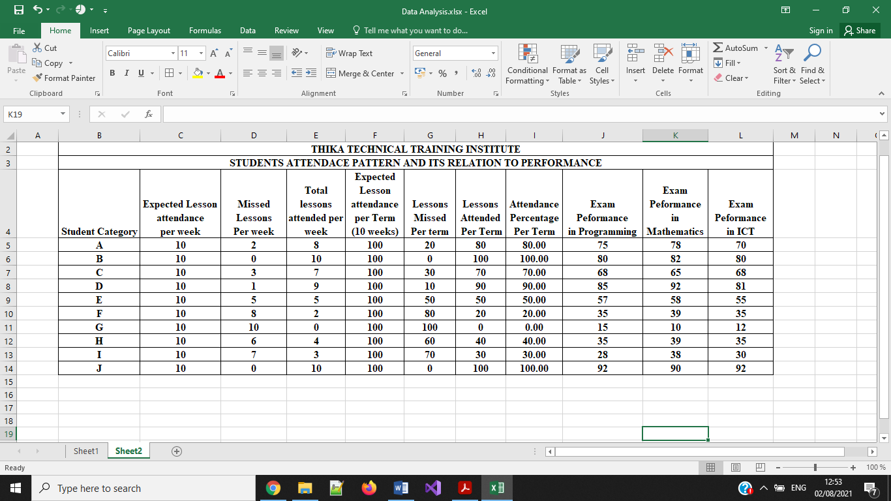The table above outlines the student’s class attendance patterns and its effects to the exam performance. The attendance has been worked out per term and represented in percentages. An analysis of three most common subject was done and represented in the following figure.

Figure 3: Attendance Percentage per Term Vs Exam Performance

The figure above clearly shows that class attendance has a direct effect to the students’ performance, those that attended all sessions seemed to attain better marks in comparison to those that missed majority of the lessons.

The new system will provide an efficient way to take attendance for each student and in return, it will help to positively influence his or her performance in exams. The system is expected to be cost effective in the sense that the cost of printing daily manual attendance registers will be eliminated.

## 3.6 System Specifications

After analysis of the collected data, the following system specifications were realized:

**User’s requirements**

**System administrator requirements**

* An easier way to enroll and manage Staffs
* An effective way to Add a course
* An effective way to Add a department
* An easier and a user-friendly way of adjusting records

**Department Administrator requirements**

* An efficient way to enroll and manage a student
* An easier way to manage a course
* An efficient way to assign units to Lecturers
* A clear way to register units taken by students

**Lecturers’ requirements**

* An efficient way to Check assigned units
* A user friendly interface to take students attendance
* Ability to generate attendance reports at ease
* A simple interface to Enter marks

**Functional Requirement.**

The new system should:

* Provide a login interface to help in authenticating the users
* Record student’s bio data in the database.
* Register courses and specific units per department.
* Have a search functionality for the users to help them quickly locate the needed record.
* Avoiding duplication of student attendance records in the database.
* Generate attendance reports

**Non-functional Requirement**

* The system should be simple and easy to learn
* The system should allow upgradability per the institute needs
* The system should improve performance in taking the class attendance and authenticating the bonifide students.

## 3.6.1 Hardware and software requirements

**Hardware requirements**

* 2.4 GHz processor
* A minimum of 4 GB of RAM
* 500 Hard Disk Capacity
* 17” Monitor
* Futronic fingerprint scanner

**Software Requirements**

* Windows 7 version and above
* Xampp web server
* Visual studio 2015 and above
* MYSQL ODBC/Connector

## 3.7 System Design

This section provides both physical and logical designs of the system.

## 3.7.1 Logical Design

The main function of the new system is to assist in automating the student attendance tracking. This is accomplished through three sections namely, the administrator, departmental administrator and the subject Lecturer, the administrator has three access rights, since he is the overall administrator of the system, and the departmental administrator has two access levels, while the lecturer accesses the lecturer module. The system flowchart in Figure 4 represents the interactions of the three users:

Figure 4: System Flow Chart

No

Enter

Marks

Yes

Are

Credentials

Correct?

Enroll/Manage Staff

Add Course

Add

Department

Generate staff

Records

Logout

student

No

No

No

Yes

Yes

Enter username and password

Administrator

Access Level

Departmental

Administrator Level

Yes

Enroll Student

Manage Student

Manage Course

Lecturer

Level

Take Attendance

Check Assigned units

Generate

Attendance reports

Figure 5: Student Authentication flow chart

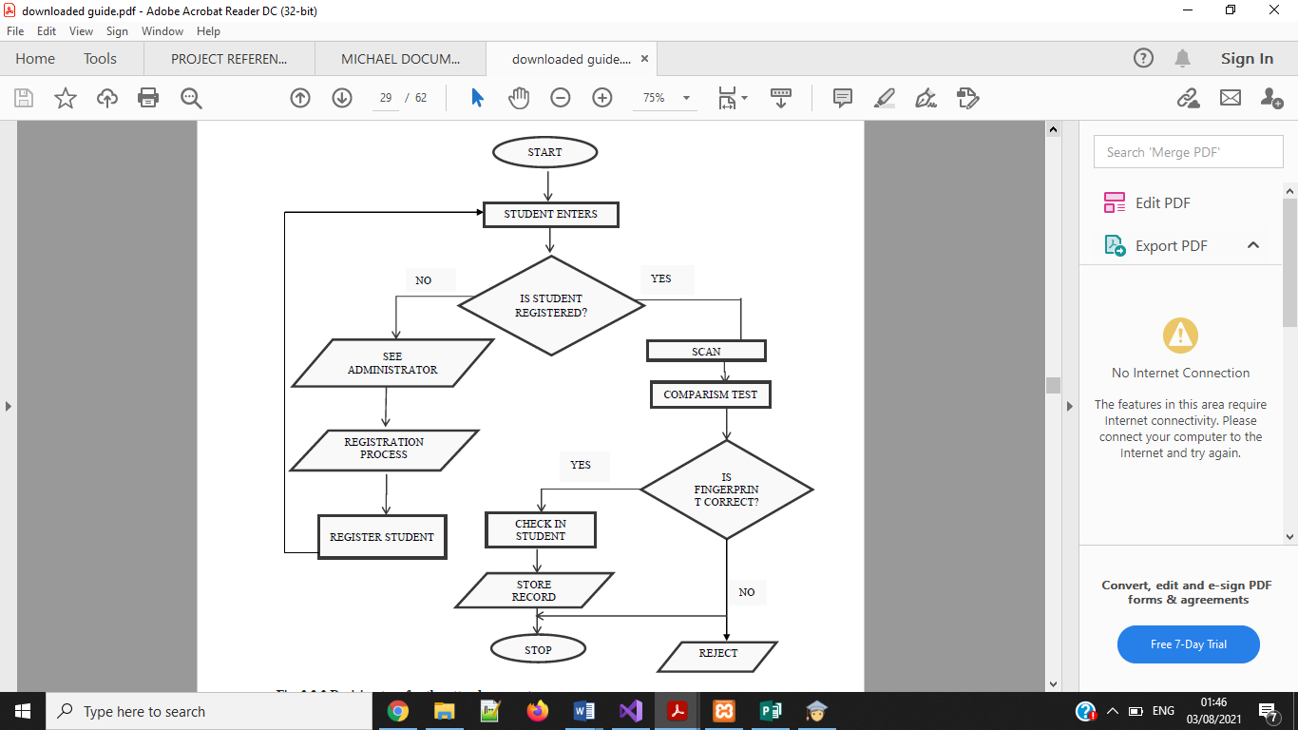

The figure above shows the mode of operation of the new system. When a student attends a lesson the lecturer I charge will initiate the attendance taking process, and the students will be asked to place his or her finger in the biometric scanner. If the student is registered, the scanned fingerprint will be matched with his bio-data stored previously in the database and his attendance will be recorded. In situations where the student was not enrolled, the unit Lecturer will refer the student to the departmental administrator for necessary registration.

## 3.8 Physical Design

## 3.8.1 Database Design

Database name: student_record_system

The system’s database will contain of the following fourteen tables;

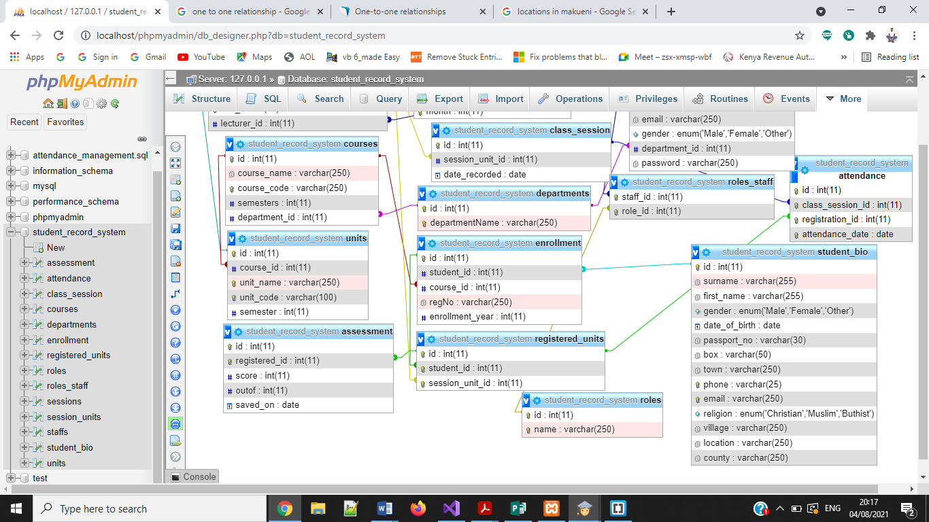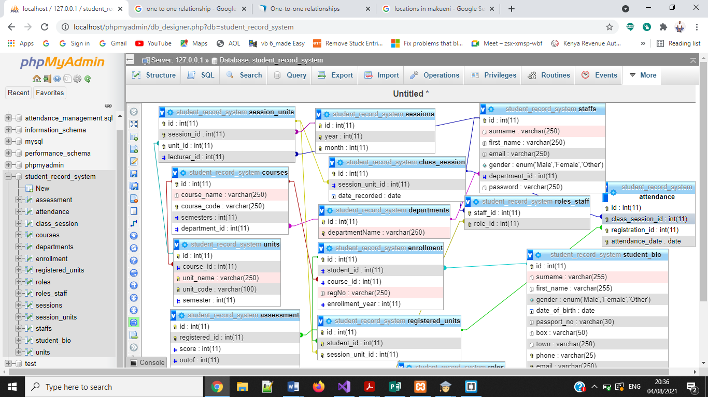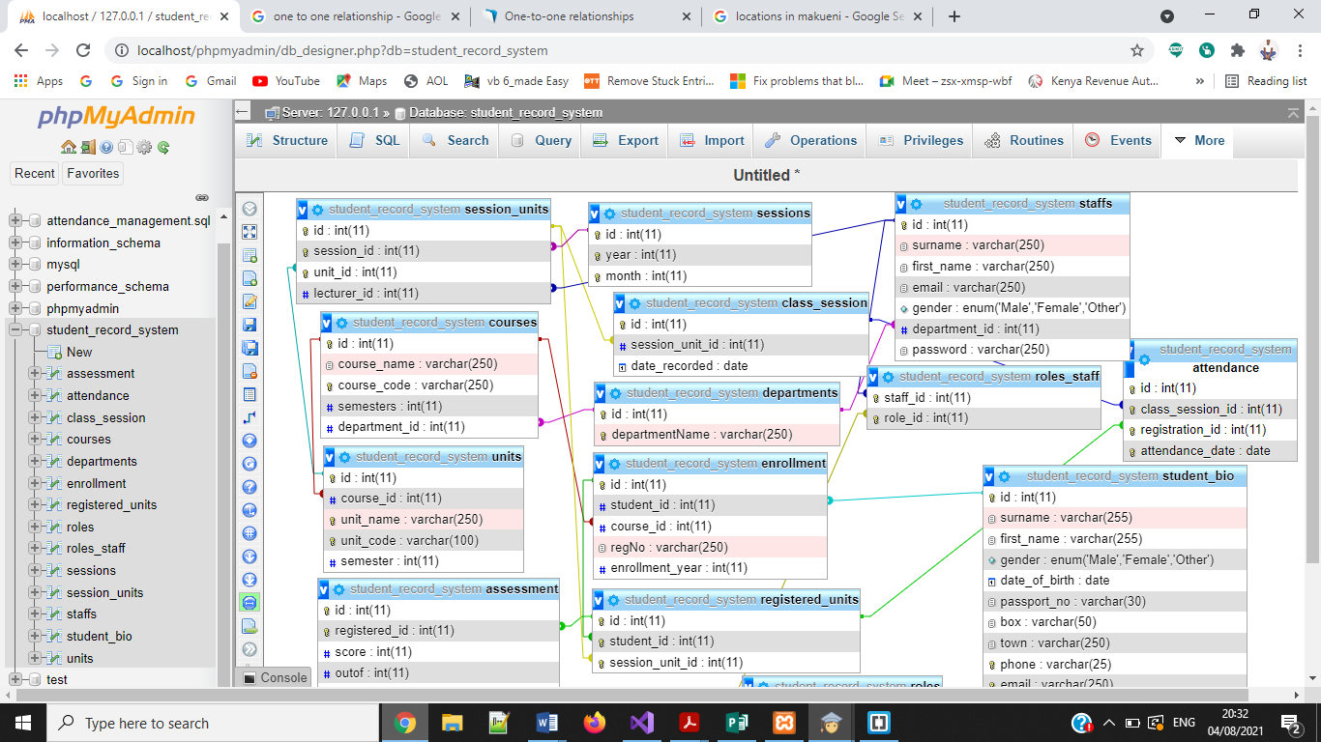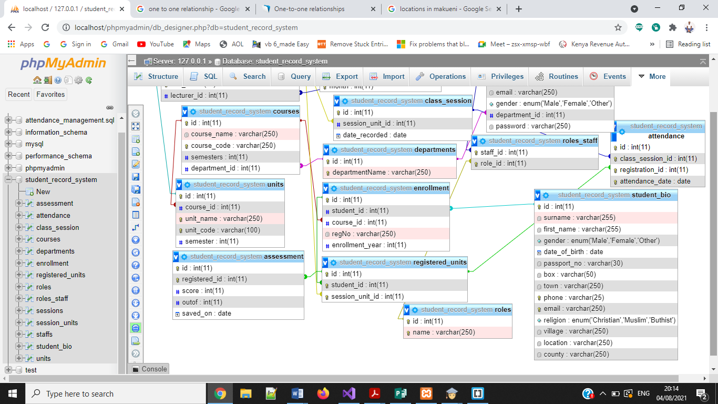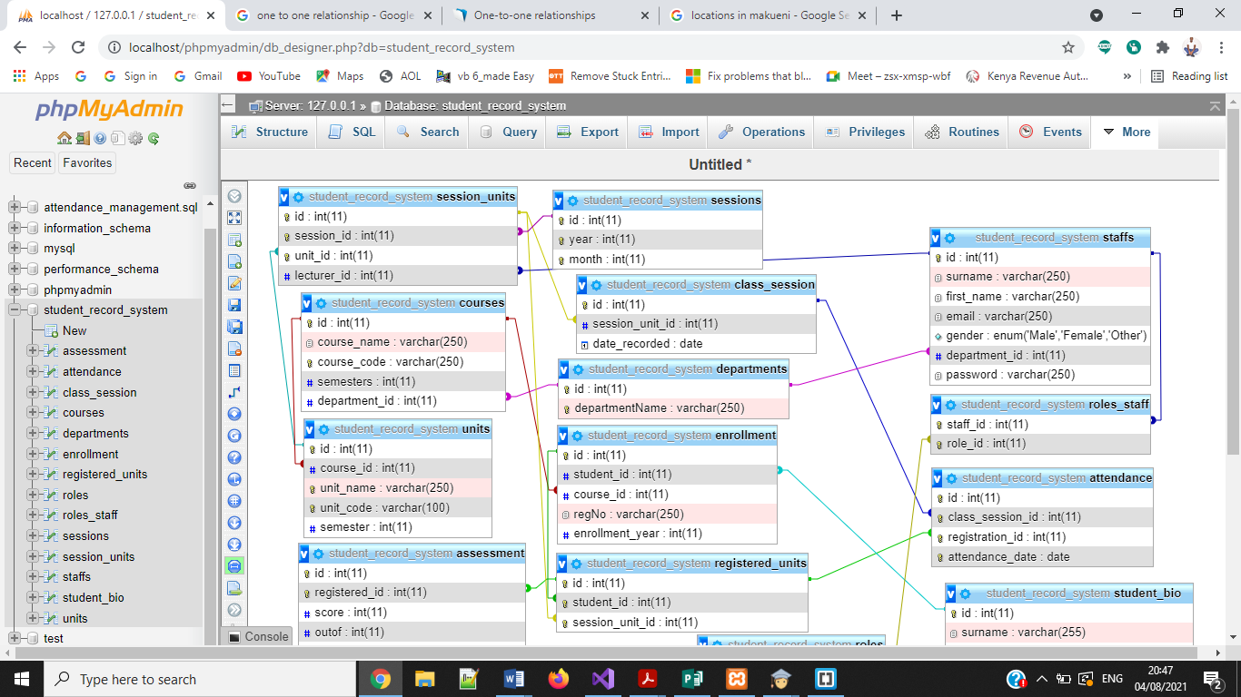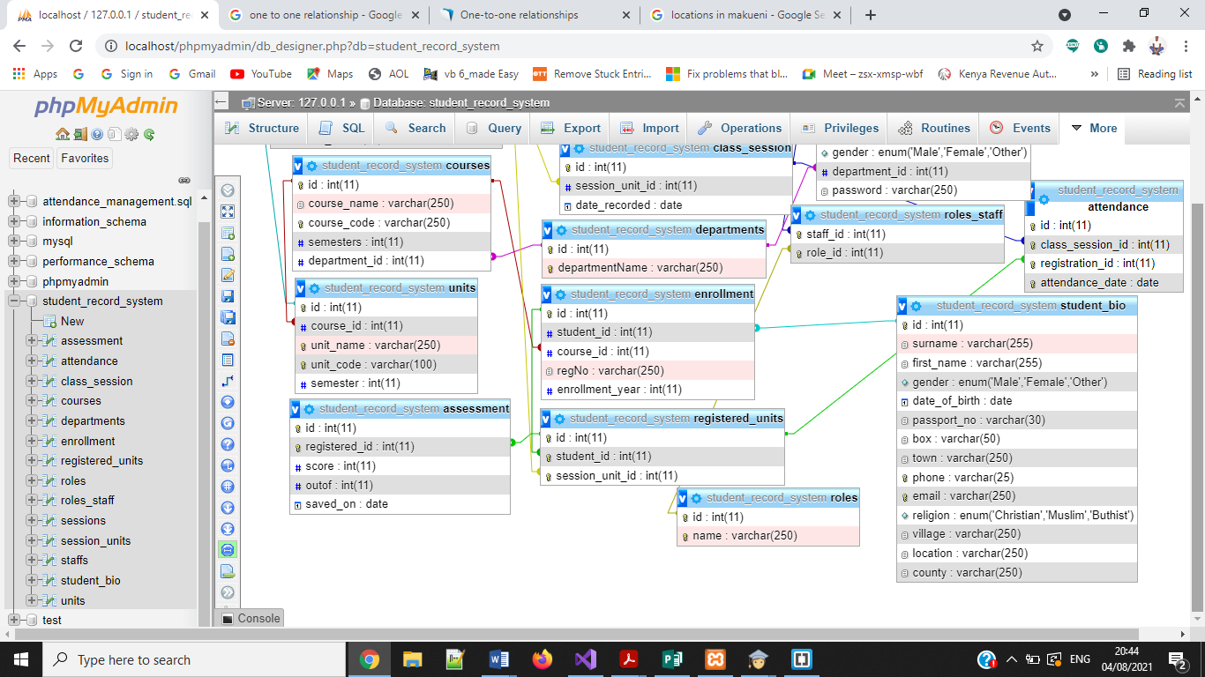

## 3.8.2 Database Entities

Figure 6: Student entity interaction with course entity

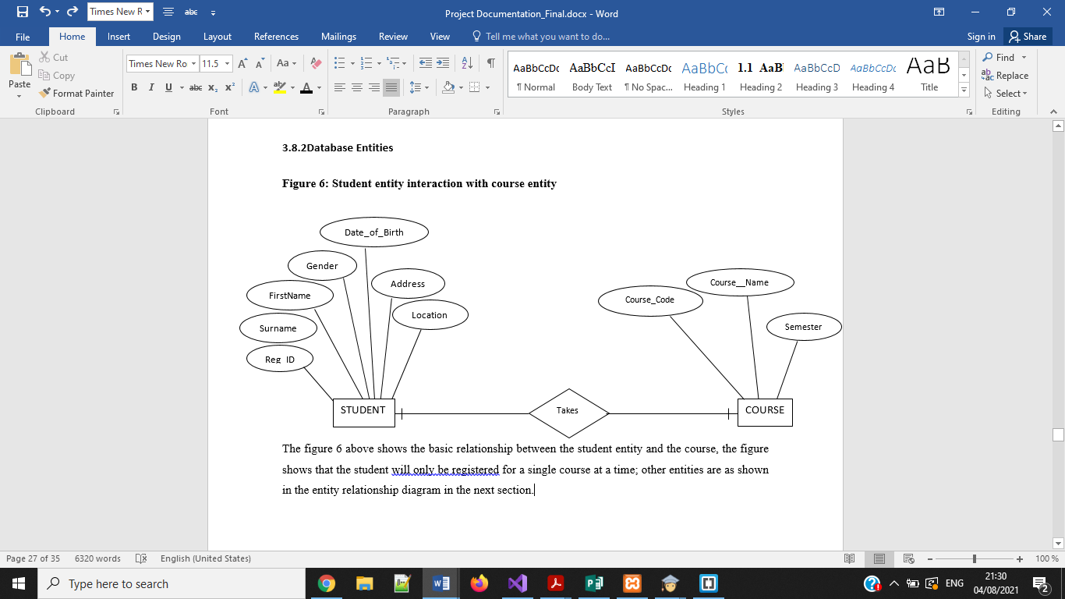

The figure 6 above shows the basic relationship between the student entity and the course, the figure shows that the student will only be registered for a single course at a time; other entities are as shown in the entity relationship diagram in the next section.

Figure 7: Entity relationship diagram for the entire attendance system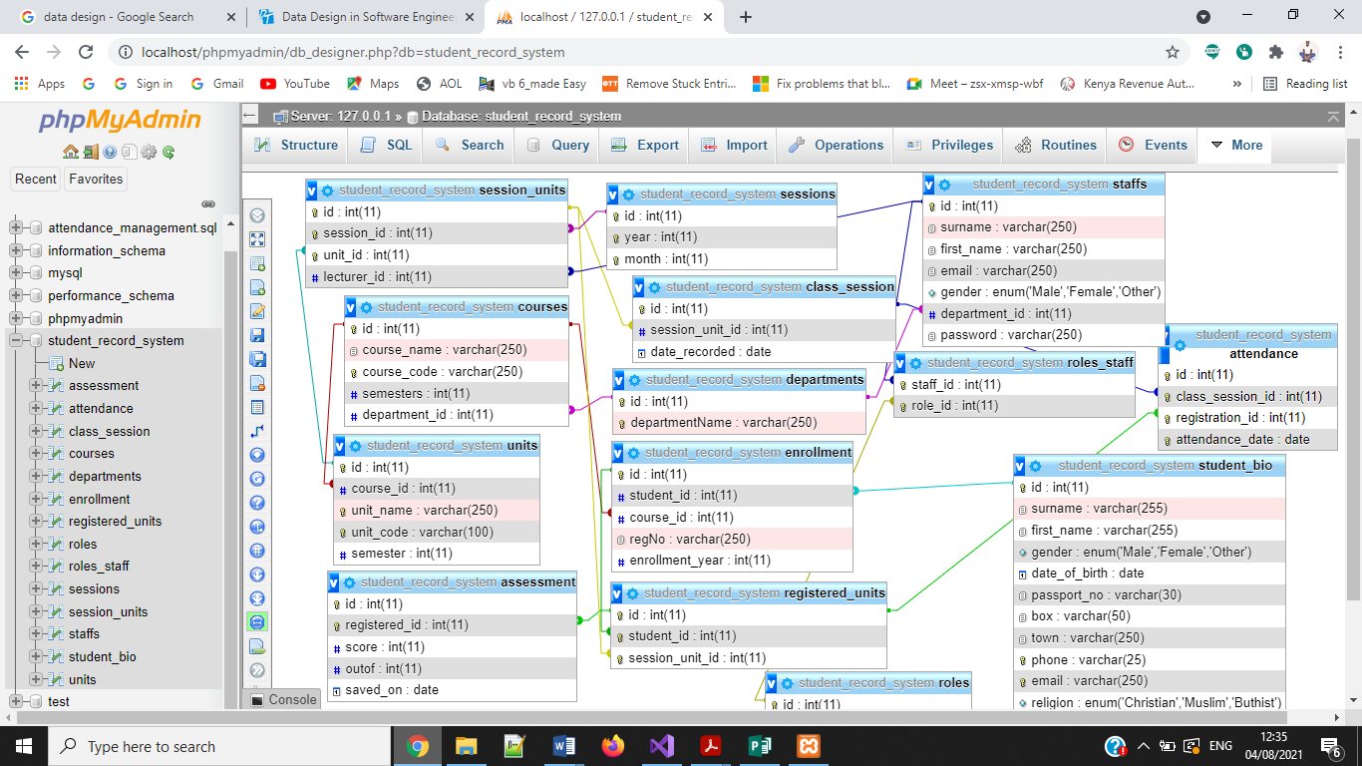

## 3.8.2 User Interface

Figure 8: Login Form

For the security of the system,all staffs will be required to login by providing their username and a password,this will help eliminate unauthorized people who may attempt to access the system.The following login form will be used.

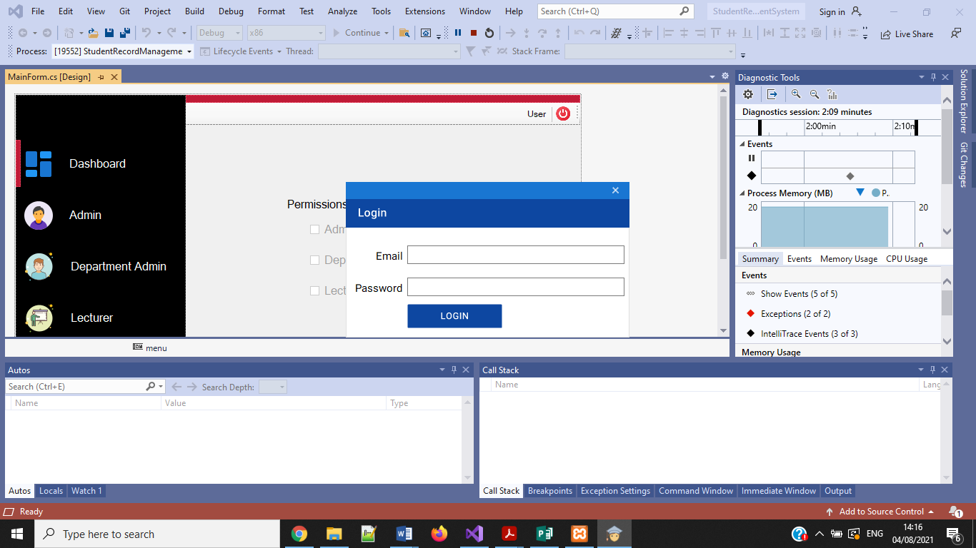

Once the user logs in, the system loads the main menu and automatically activates or deactivates the menu depending on the user’s access rights.

Figure 9: Main Menu with Administrator rights

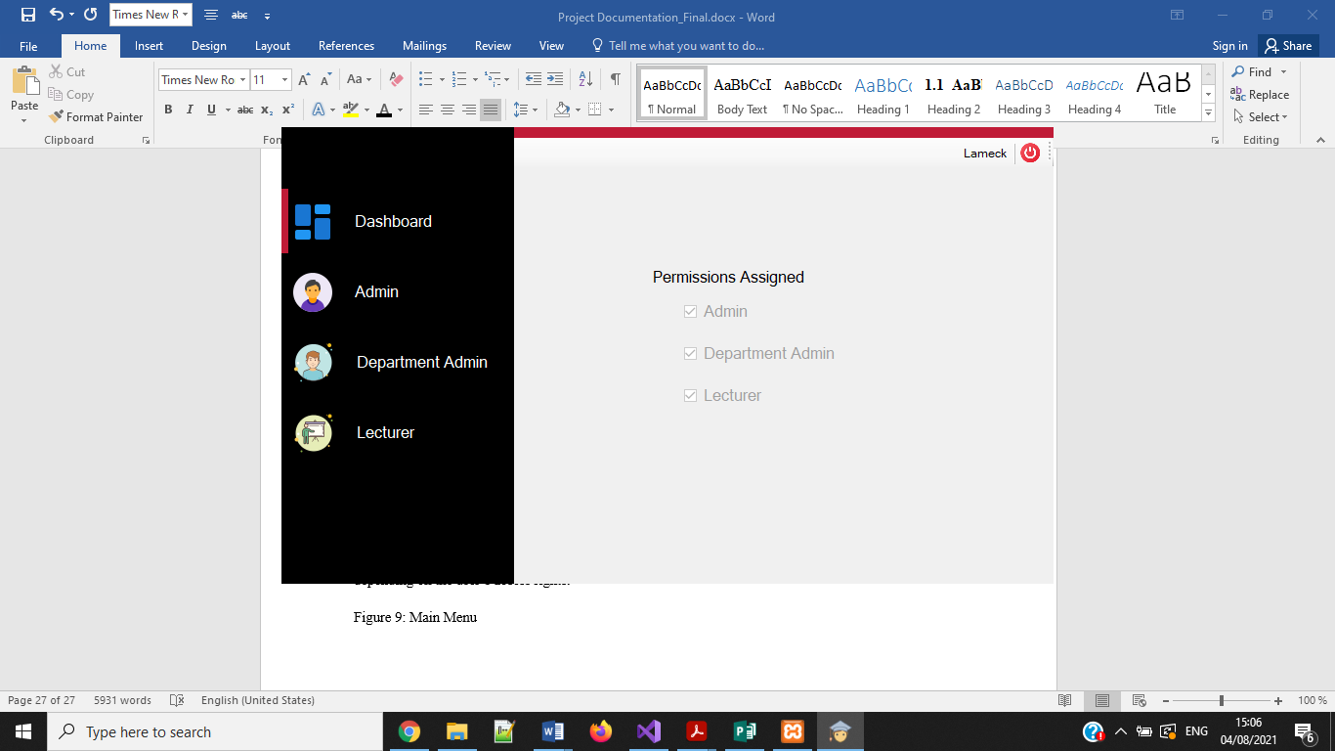

Figure 10: Main Menu with Lecturer rights

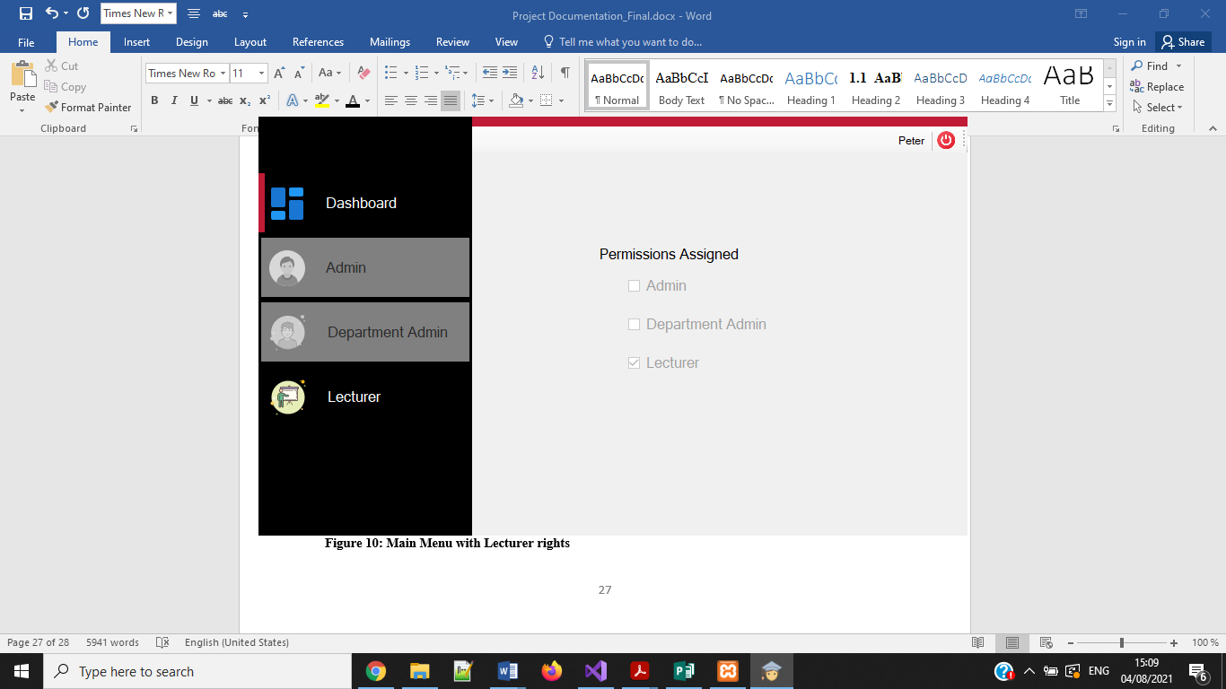

Figure 11: Staff Registration Function

This form will be used to register new staff and assign them the specific roles; it is the responsibility of the administrator to add any new staff to the system

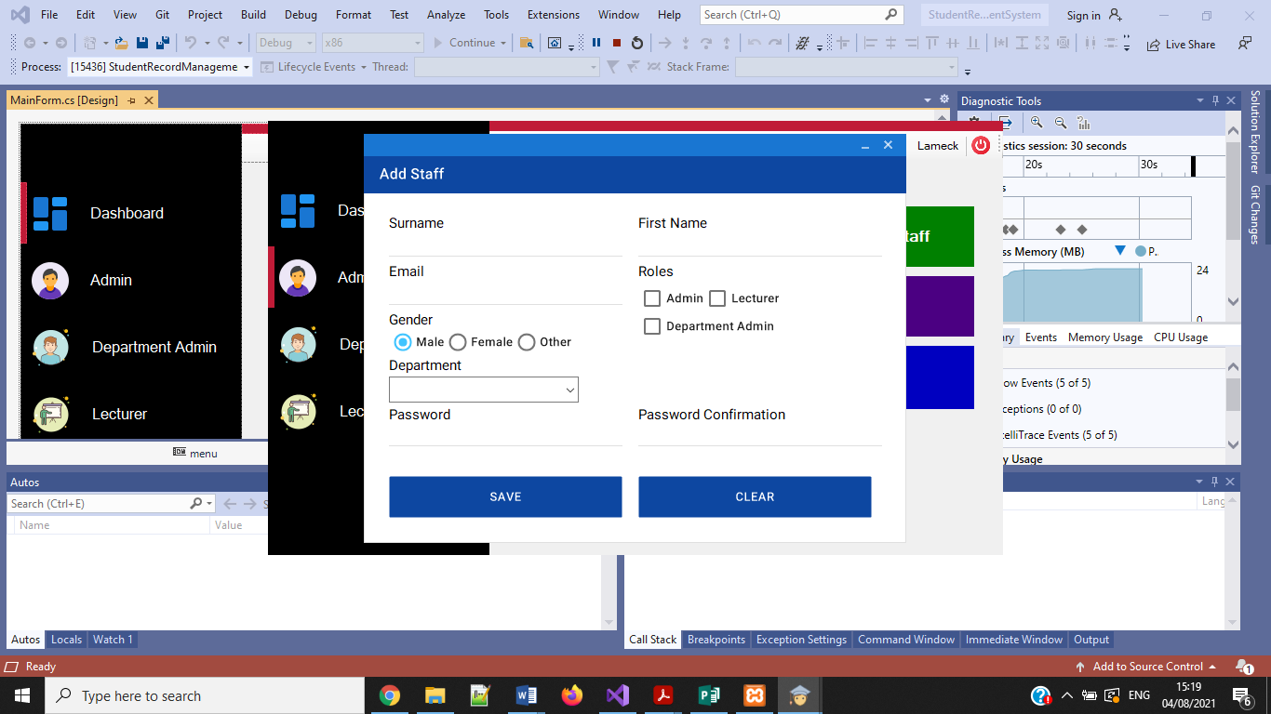

Figure 12: Student Registration Function

This form will be used to register the students’ bio-data. It is the role of the departmental administrator to register the students and therefore this form is found under his module.

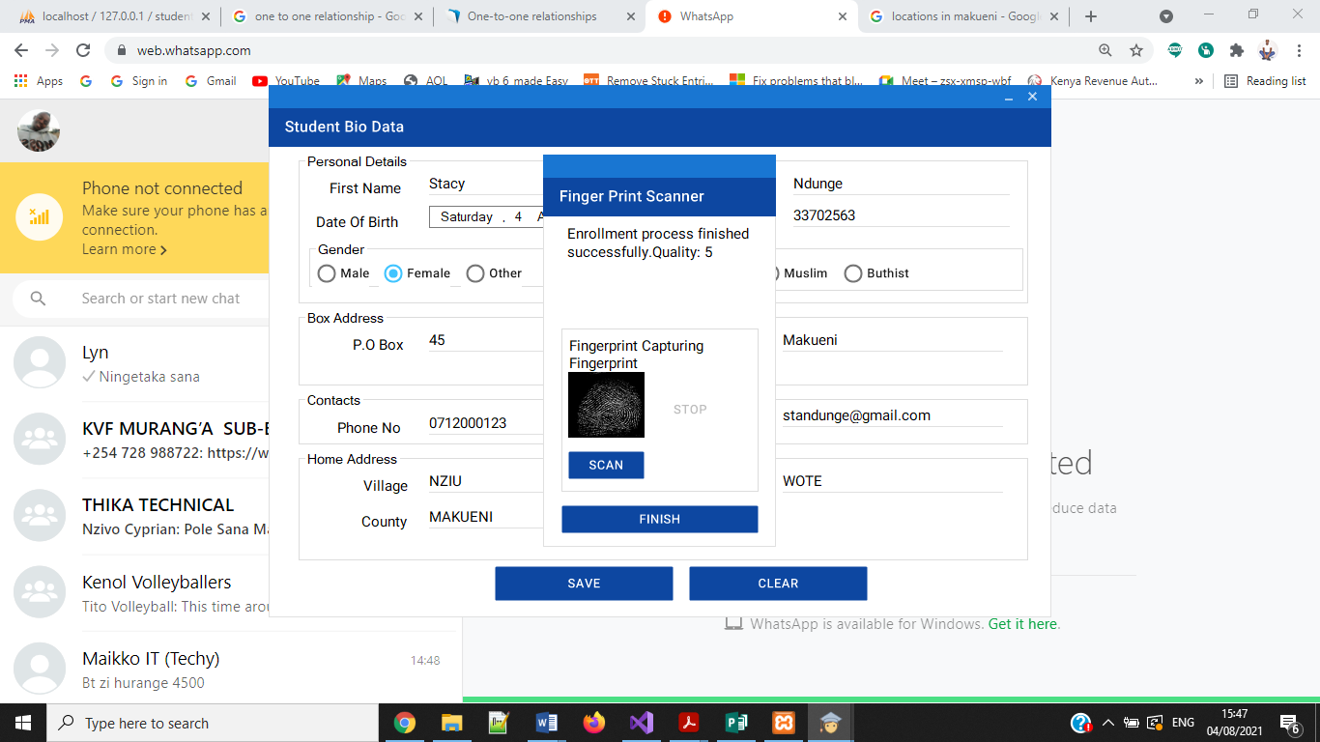

After scanning the student’s finger, the departmental administrator will click finish and the new record will be saved.

Figure 13: Course Management Function

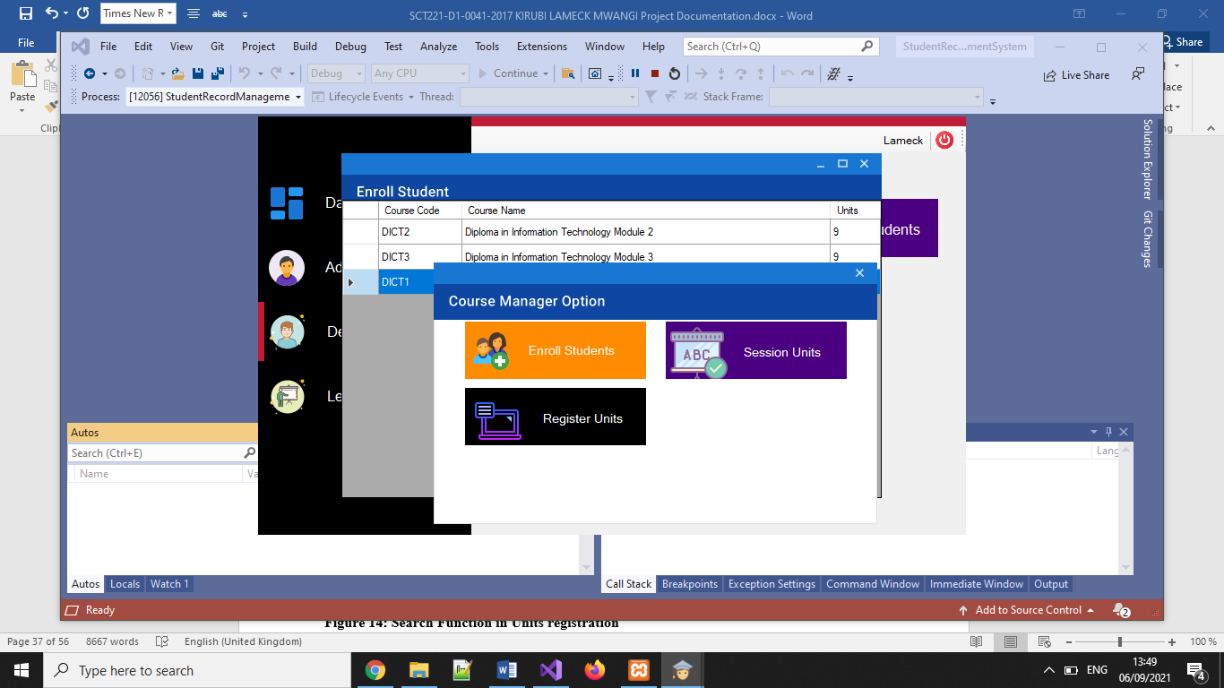

The departmental administrator uses the above module to, enroll students to a course, register units, activate a session and assign units to the lecturers

Figure 14: Search Function in Units registration

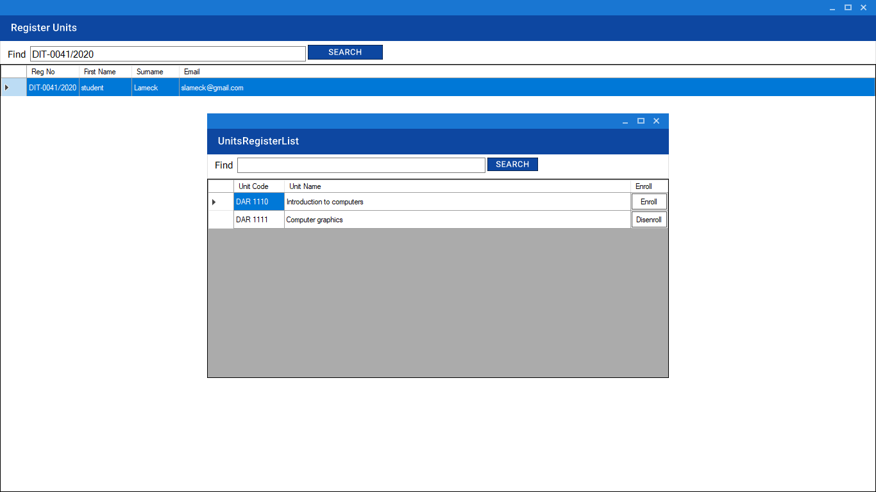

Figure 15: Student Attendance Taking function

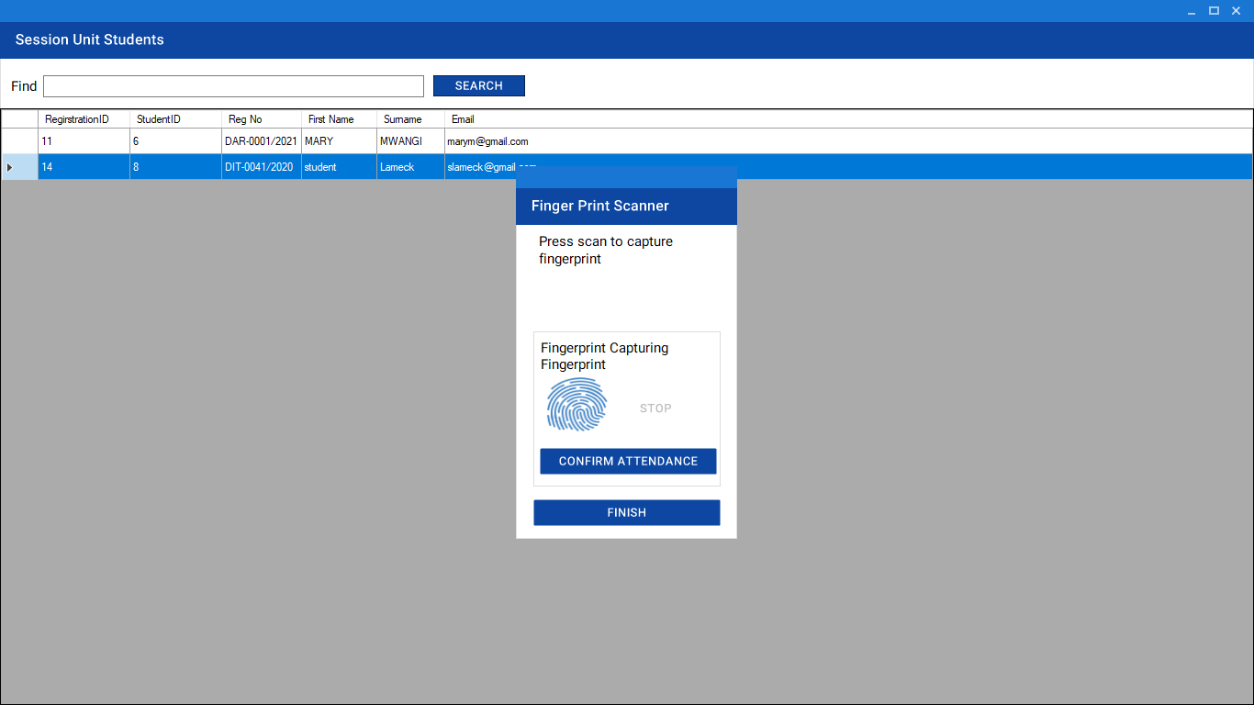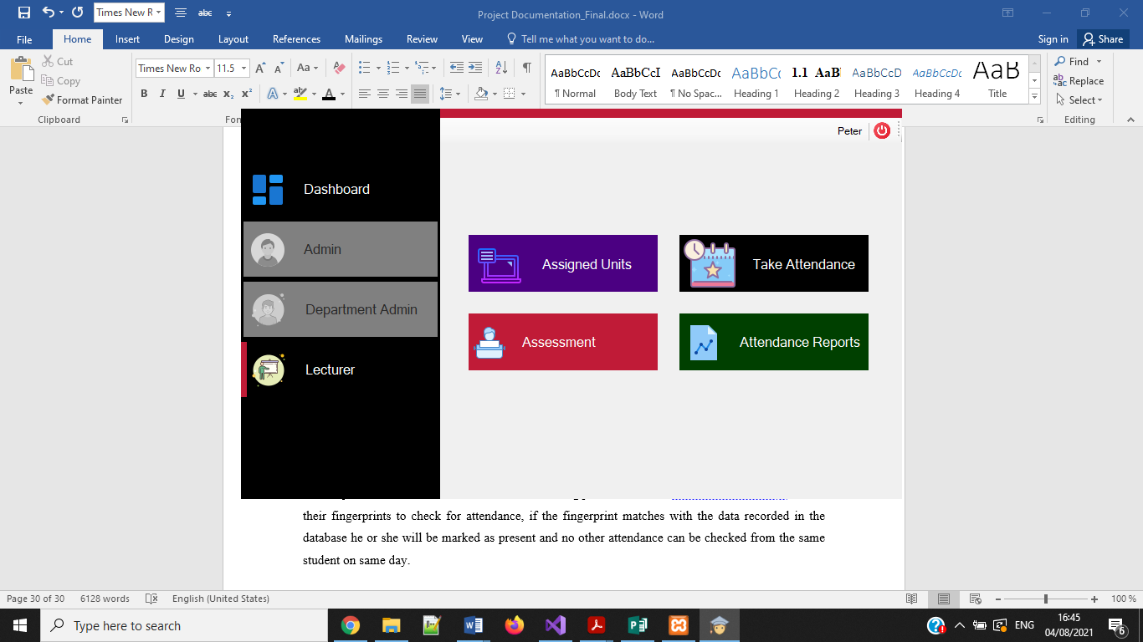

The subject Lecturer will initiate the attendance taking process; students will therefore be asked to scan their fingerprints to check for attendance, if the fingerprint matches with the fingerprint recorded in the database he or she will be marked as present and no other attendance can be accepted from the same student on same day.

Figure 16: Marks Entry Function

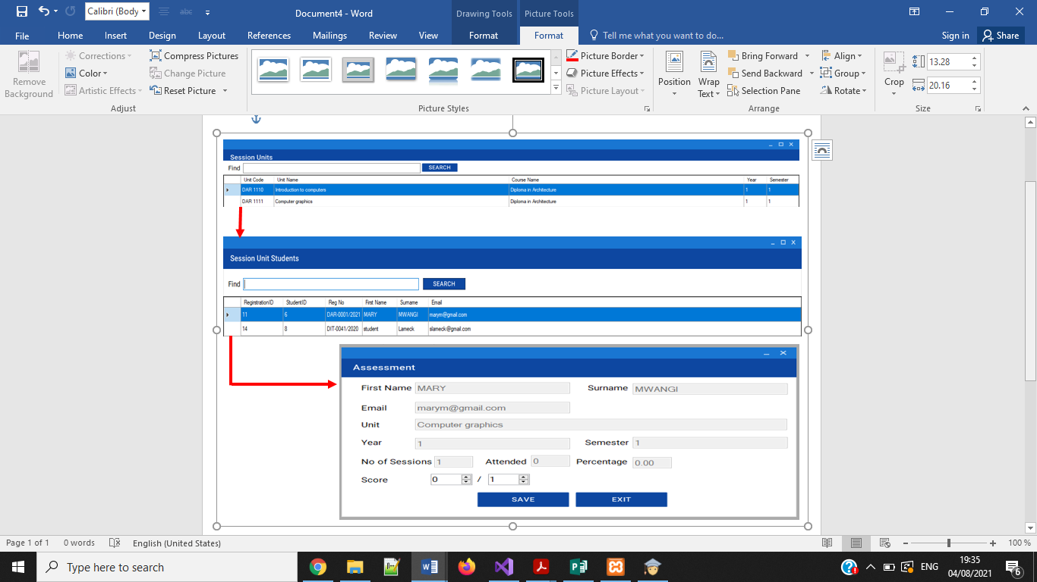

The subject lecturer will use this function to enter end of term marks scored by each student out of a possible hundred marks. Prior processes like choosing the session, choosing the unit, and the student from whom to enter the marks will need to be done.

## 3.8.3 Control Design

These processes are carried out to validate the various processes that are carried out during the various processing tasks that will be carried out when the system is operational. Thus, controls were made to ensure that the system functions as expected. These controls include:

1. **Input Control**

This control ensures that the data entered is in the correct format and that it’s the one that is being processed and saved in the database. i.e.

* On screen notifications to show a successful and complete process

Figure 17: Example of Input Control

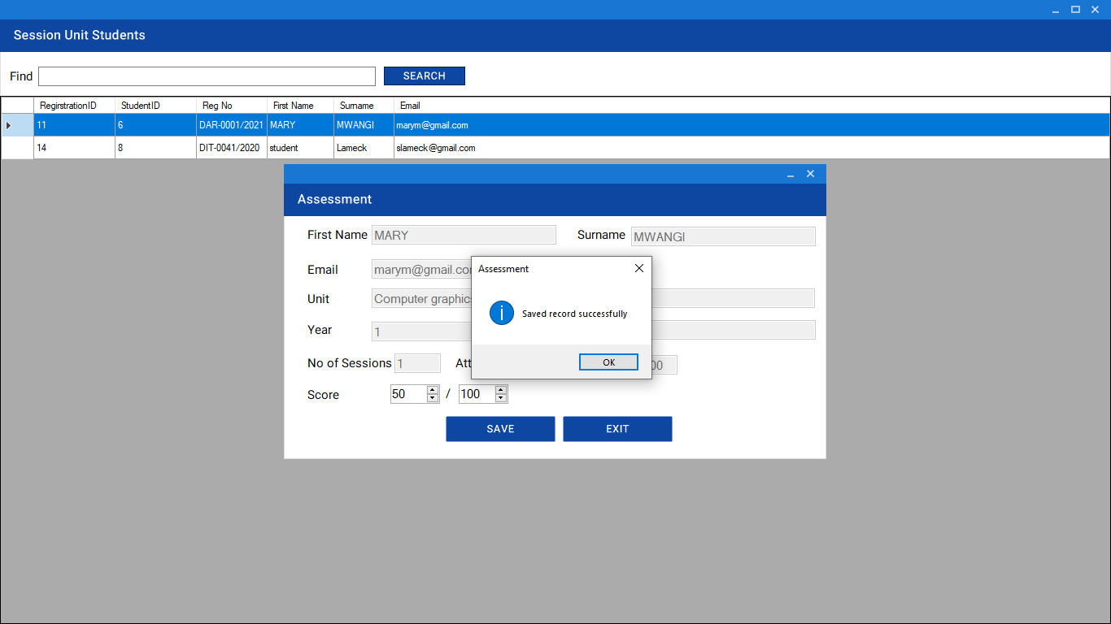

**2. Output Control**

Outputs will be clear and precise on the reports with their respective dates and information required. For instance, a report on the staffs registered on the database is shown in figure 18 below

Figure 18: Systems Staff Report

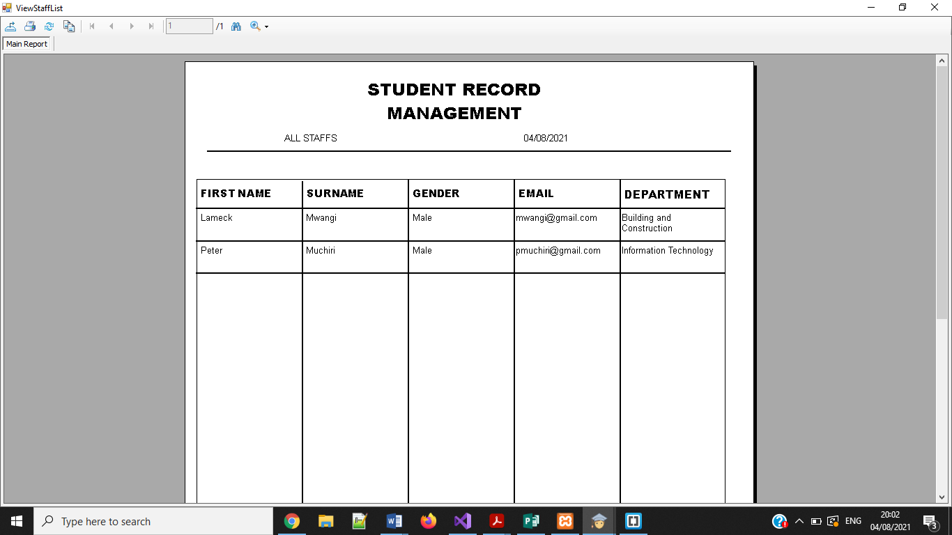

# **CHAPTER 4: IMPLEMENTATION AND TESTING**

## 4.1 Introduction

This chapter describes how the system requirements formulated during analysis were translated into a functional system.

## 4.2 Implementation

During system development the following tools were used;

1. **Microsoft visual studio** – This provided an integrated development environment, which was used for creating, running and debugging programs that were written.
2. **C# Programming Language** – This is the programming language that was used to generate source code. This facilitated integration of logic onto different graphical user components used.
3. **Microsoft Office Suite**– This offered Microsoft Word and PowerPoint that were used for documenting the system and system presentations respectively.
4. **Futronic SDK**- This is a standard development kit that enabled capture the student’s bio data through fingerprint scanning.
5. **MySQL ODBC-**A driver that helped connect to a MySQL database server through the Open Database Connectivity (ODBC) application program interface (API).
6. **MYSQL Connector-** This connector provides standards-based drivers for ODBC, and .Net. This enabled the developer to build the database applications in his language of choice
7. **Web Server [Xampp]-** This was used to provide support for creating and manipulating databases in MYSQL
8. **Crystal Reports for Visual Studio**-This was used to provides a comprehensive reporting solution

With the help of the above tools, different components were integrated to create a fully functional system. For deployment of the system on the users end an installation guide was added in the software package

## 4.3 System Code Generation

This section shows a sample code that have been used to implement several elements of the student tracking system

1. **Database connection**

<?xml version="1.0" encoding="utf-8" ?>

<configuration>

<startup>

<supportedRuntime version="v4.0" sku=".NETFramework,Version=v4.5.2" />

</startup>

<connectionStrings>

<add connectionString="server=localhost;user=root;pwd=;database=student_record_system" name="student_system" providerName="MySql.Data.MySqlClient"/>

</connectionStrings>

</configuration>

1. **Partial Login Code**

namespace StudentRecordManagementSystem

{

public partial class Login : MaterialForm

{

public Login()

{

InitializeComponent();

}

private void Login_Load(object sender, EventArgs e)

{

var materialSkinManager = MaterialSkinManager.Instance;

materialSkinManager.AddFormToManage(this);

materialSkinManager.Theme = MaterialSkinManager.Themes.LIGHT;

materialSkinManager.ColorScheme = new

ColorScheme(Primary.Blue900, Primary.Blue700,

Primary.BlueGrey500, Accent.LightBlue200, TextShade.WHITE);

}

private void btnLogin_Click(object sender, EventArgs e)

{

try

{

StaffAuthModel staff;

validateUserInput();

string email = txtEmail.Text;

string password = txtPassword.Text;

staff = StaffAuthenticationManager.loginStaff(email, password);

MainForm main = new MainForm();

main.staff = staff;

main.loginForm = this;

this.Hide();

main.Show();

}catch(Exception ex)

{

showErrorMessage(ex.Message);

}

}

private void validateUserInput()

{

if (txtEmail.Text.Length < 5)

throw new InvalidInputException("email");

if (txtPassword.Text.Length < 4)

throw new InvalidInputException("Password", 4);

}

private void showErrorMessage(string message)

{

MessageBox.Show(message, this.Text, MessageBoxButtons.OK, MessageBoxIcon.Error);

}

public void clearInput()

{

txtEmail.Text = "";

txtPassword.Text = "";

}

## 

## 4.4 System Testing

Testing is a process that was extensively done to ensure that the system met most of the specified requirements. The process of testing began immediately when the system development process started. A number of testing types were done and they included unit testing, integration testing and system testing. Unit testing was carried on every module completed to ensure that it performed as required. Whenever, two or more modules were integrated, integration testing was then performed to ensure that the involved modules communicated and performed as per the expectations. The final type of testing done was system testing in which, the fully integrated system was evaluated based on the expectations. It is in this testing that validation was done through supplying the system with both valid and invalid data and observations were made. Detected errors were rectified. As a source of sample data, several staffs were added as employees with different access levels whose credentials were then used to login differently and access different sections of the system respectively.

## 

## 4.4.1 Testing Cases and Results

Table 4: Testing Installation and the Login function

|  |  |  |  |  |
| --- | --- | --- | --- | --- |
| **Test case**  **Number**  **D** | **Task** | **Expected result** | **Actual result** | **Status** |
| **Case 1** | Installation of the system | System to install and display login screen | System installs and display login screen | **Pass** |
| **case 2** | Login= (blank)  Password=  (blank) | A window  “You entered invalid email” must  be shown to the  user and access  must not be  granted. | A window  “You entered invalid email ” is  shown to the user  and access is not  granted. | **Pass** |
| **case 3** | Username= Incorrect  Password=correct | A window  “Incorrect  credentials” must  be shown to the  user and access  must not be  granted. | A window  “Incorrect  credentials” is  shown to the user  and access is not  granted. | **Pass** |
| **case 4** | Username= Correct  Password=Incorrect | A window  “wrong username or password” must  be shown to the  user and access is  denied. | A window  “wrong username or password ” is  shown to the user  and access is denied | **Pass** |
| **case 5** | Username= Correct  Password=Correct | Access must be  granted to the  user and main screen displayed | Access is granted  to the user  and main screen displayed | **Pass** |

Table 5: Student attendance checks

|  |  |  |  |  |
| --- | --- | --- | --- | --- |
| **Test Case Number** | **Task** | **Expected result** | **Actual Result** | **Status** |
| **Case1** | Place the stored finger to confirm attendance | Successfully verified  ”student email”, then a window  “attendance details saved” | Successfully verified  ”student email”, then  “attendance details saved” | **Pass** |
| **Case 2** | Place the un-stored finger to confirm attendance | “Verification failed” then a window  “Failed to verify fingerprint” shown | “Verification failed” then a window  “Failed to verify fingerprint” shown | **Pass** |
| **Case 3** | Place the stored finger to confirm attendance the second time | Successfully verified  ”student email”,  then a window  “already took attendance for today” shown | Successfully verified  ”student email”,  then a window  “already took attendance for today” shown | **Pass** |

Table 6: Data Entry Checks

|  |  |  |  |  |
| --- | --- | --- | --- | --- |
| **Test Case Number** | **Task** | **Expected result** | **Actual Result** | **Status** |
| **Case1** | Admin register a new staff | The system generates a message “saved staff details successfully” | The system generates a message “saved staff details successfully” | **Pass** |
| **Case 2** | Admin viewing the staff report | The system generates a  staff report | The system generates a  staff report | **Pass** |
| **Case 3** | Admin attempts to register a new staff with an already used email | The system generates a message “Staff with similar email already exists” | The system generates a message “Staff with similar email already exists” | **Pass** |

## 4.5 Conclusion

Despite the fact that a few challenges were experienced during the research and system development, the entire process proved interesting and beneficial. First, the research conducted under this study offered the researcher an understanding of different principles of system usability and how usability can be enhanced in a system. Secondly, the researcher got an opportunity to practice and explore different areas taught during his degree course. In particular, during the system development a lot of knowledge was gained in programming and database development, which left the researcher a more experienced individual.

## Limitation

All systems will always be exposed to one or more limitations spanning from data integrity, data security or high maintenance costs. The developed system will be faced by the following limitations

* High cost of the Biometric identification systems inclusive of the Software Development Kit (SDK).
* The fingerprint reader can only take one fingerprint at a time during the enrolment process, this slows down the enrolment process since all ten fingerprints all captured and stored in a reference library.
* It is not applicable to amputated students, since they don’t have fingers to put on the scanner
* Possibility of type I and type II errors. This is the rejection of authorized persons and the acceptance of unauthorized persons respectively. This limitation is common to all Biometric devices.

## 4.7 Recommendations

A Well-developed software can take a number of years to be completed; these include the software going through series of research and tests. The researcher recommends for a further advancement in the development of the system where more features that enhance learnability. For an effective deployment of the system, the developer also recommends that:

* Stakeholders in the institute should be involved in the implementation of the software.
* Stakeholder should also make funds available to purchase fingerprint scanner to implement the project.
* The system can be further developed to meet the limitations stated
* A more complex security measure in the form of access methods and authorization can be adopted for the system to meet the ever-changing technology.

# **REFERENCES**

* Ridnouer, K. (2016). Managing your classroom with heart. Alexandria, Va.: Association for Supervision and Curriculum Development.
* Newman, R. (2010). Security and access control using biometric technologies. Clifton Park, N.Y: Delmar.
* Sprick, J., & Sprick, R. School leaders guide to tackling attendance challenges.
* Patrick, A., and Mu, S. (2014). Usability and Acceptability of Biometric Security Devices, (accessed online: http://www.andrewpatrick.ca/biometrics/index.shtml)
* Hailpern and santhanam (2018) , software debugging, testing and verification. Reeds: Scribed inc
* IEEE, Software Engineering, 1999 Edition, Complete 4-Volume Set, Institute of Electrical and Electronic Engineers, Inc., 1999
* Jain, A. K. [2019]. Biometrics: A Tool for Information Security – IEEE.
* Markowitz, J. A. (2016). Using Speech Recognition. New Jersey: Prentice Hall PTR. ISBN 0131863215, 9780131863217.
* Dix, A., Finlay, J., Abowd, G., & Beale, R. (1998). Human Computer Interaction.
* Elliott, G., Jones, E., & Barker, P. (2002). A grounded theory approach to modeling learnability of hypermedia authoring tools. Interacting with Computers, . 14,547-57

# **APPENDICES**

## Appendix 1: Sample Questionnaire for Lecturers

Introduction:

Kirubi Lameck Mwangi has prepared this questionnaire for a research project. Lameck is a final year student at Jomo Kenyatta university of Agriculture and Technology pursuing a Bachelor of Science in information Technology. The research project is to help the management and Lecturers of Thika Technical Training institute to accurately track and document the Student’s class attendance. Your feedback is important for the successful completion of this study. Kindly take some time and answer it by indication through ticking and giving detailed answers where possible.

**SECTION A: PERSONAL DETAILS**

1. Gender:

☐ Male

☐ Female

2. Teaching Experience in Years

☐ Below 2 ☐ 3-5 ☐ Above 5

3. Department:

* Health and applied sciences
* Building and civil engineering
* Information communication technology
* Electrical and electronics engineering
* Business studies
* Mechanical engineering

**SECTION B: SYSTEM INFORMATION**

1. Do you check the students class attendance ☐ Yes ☐ No

2. If yes, how do you check the student class attendance?

☐Student’s register on a form during the lesson

☐ calling the students name as you tick in a printed booklet

Other_________________________________________________

3. How many times do you check the student class attendance in a day?

Once ☐

Twice ☐

More than twice☐

4. Is the method used to track the attendance accurate? ☐ Yes ☐ No

5. Would you like the current class attendance tracking method to be improved to use biometric? ☐ No ☐ Yes

6. What are the considerations when calculating the student’s termly attendance percentage? _*___________________________________________________________________________________________________________*_

7. How do you rate your computer literacy skills?

☐ Poor

☐ Average

☐ Excellent

8. Should the proposed biometric fingerprint tracking system be adopted as a desktop application? ☐ Yes ☐ No

## Appendix 2: Key Interview Questions for the Management

1. What are the roles of the Principal in student’s management?
2. What are the roles of Deputy Principal Academics in student’s management?
3. What are the roles of a Head of department?
4. Is there a system whether manual or electronic that assist you in tracking students attendance?
5. How does the current system operate?
6. What are the methods/tools used to perform daily tasks?
7. How long does it take to mark attendance of one student manually?
8. Are the lecturer’s able to maintain integrity and consistency in student attendance tracking?
9. Biometric systems have been used in similar operations as yours, would you support deployment of such a system to enhance efficiency in your student’s record management?
10. If such a system is implemented, is the management willing to offer the needed support such as training the users?

## Appendix 3: Installation Guide

******REQUIREMENTS******

1. Visual Studio

2. MySQL ODBC -- preferred version 5.*[32 BIT]

3. MySQL connector - preferred version 5.* or 6.*[32 BIT]

4. Crystal Report for Visual Studio

5. Web Server - [Xampp or Wamp server]

******PROCESS*******

1. Install Visual Studio first

2. Install web server.

3. Create new database "student_record_system"

4. Import the SQL Table file that you will export from your server

5. If Visual Studio is opened close before installation of crystal-reports engine

6. Install MySQL ODBC

7. Open visual studio and run the system.

## Appendix 4: Budget and resources

Table 7: Budget and resources

|  |  |  |  |
| --- | --- | --- | --- |
| **No** | **Item Description** | **Available** | **Estimated cost(Kshs)** |
| 1 | Personal computer | **🗸** |  |
| 2 | Flash memory | **🗸** |  |
| 3 | Futronic SDK | ☒ | 15000 |
| 4 | Documentation printing and binding | ☒ | 2000 |
| 5 | Stationeries | ☒ | 500 |
| 6 | Visual studio 2019 | ☒ | 20000 |
| 7 | XAMPP Server | **🗸** |  |
| 8 | Text Editor | **🗸** |  |
| 9 | Browser(Mozilla Firefox 2020) | **🗸** |  |
| 10 | Internet Expenses | ☒ | 1000 |
| 11 | Research Expenses | ☒ | 3000 |
| 12 | Fingerprint scanner | ☒ | 10000 |
| Grand Total | | | 51500 |

## Appendix 5: Work Plan

Figure 19: Gantt chart showing the Development of The System

|  |  |  |  |  |  |  |  |  |  |  |  |  |  |  |  |  |  |  |  |  |
| --- | --- | --- | --- | --- | --- | --- | --- | --- | --- | --- | --- | --- | --- | --- | --- | --- | --- | --- | --- | --- |
| **ACTIVITY** | **PERIODS IN WEEKS** | | |  |  |  |  |  |  |  |  |  |  |  |  |  |  |  |  |  |
| **1** | **2** | **3** | **4** | **5** | **6** | **7** | **8** | **9** | **10** | **11** | **12** | **13** | **14** | **15** | **16** | **17** | **18** | **19** | **20** |
| **Proposal Writing** |  |  |  |  |  |  |  |  |  |  |  |  |  |  |  |  |  |  |  |  |
| **Feasibility Study** |  |  |  |  |  |  |  |  |  |  |  |  |  |  |  |  |  |  |  |  |
| **Fact Finding** |  |  |  |  |  |  |  |  |  |  |  |  |  |  |  |  |  |  |  |  |
| **Requirement Specification** |  |  |  |  |  |  |  |  |  |  |  |  |  |  |  |  |  |  |  |  |
| **Logical Design** |  |  |  |  |  |  |  |  |  |  |  |  |  |  |  |  |  |  |  |  |
| **Physical Design** |  |  |  |  |  |  |  |  |  |  |  |  |  |  |  |  |  |  |  |  |
| **System Coding** |  |  |  |  |  |  |  |  |  |  |  |  |  |  |  |  |  |  |  |  |
| **Testing** |  |  |  |  |  |  |  |  |  |  |  |  |  |  |  |  |  |  |  |  |
| **Implementation** |  |  |  |  |  |  |  |  |  |  |  |  |  |  |  |  |  |  |  |  |
| **Documentation** |  |  |  |  |  |  |  |  |  |  |  |  |  |  |  |  |  |  |  |  |